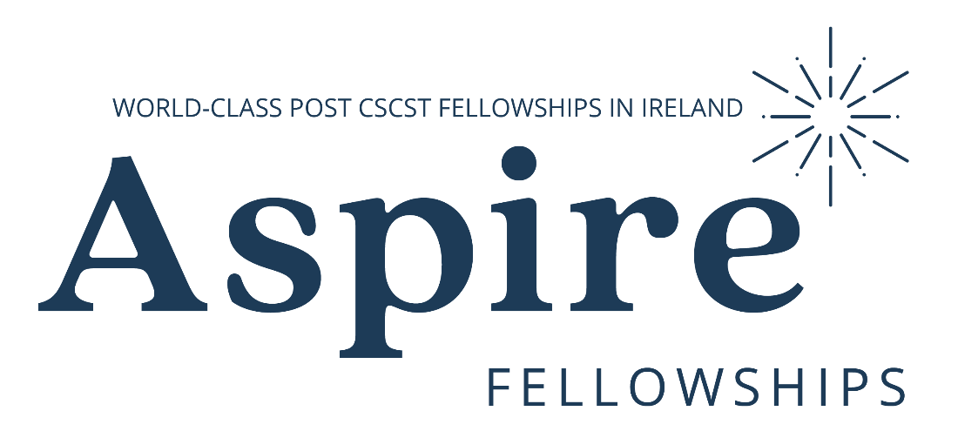
CSCST Fellowships July 2024
Applicant’s Coversheet

SECTION A: APPLICANTS WHO ARE CURRENTLY TRAINING AND EXPECT TO COMPLETE THEIR TRAINING BY JULY 2024 MUST COMPLETE THIS SECTION:

First Name:
Middle Name (s):
Last Name:
Expected date of CCST:

Please also supply an up to date Curriculum Vitae and a summary logbook with your application.

Please return the completed applicant’s coversheet, a copy of your CV and your summary logbook to rebecca.martin@eyedoctors.ie

Deadline for submission of applications: 5pm 4th December 2023

SECTION B: APPLICANTS WHO HAVE BEEN AWARDED CCST BETWEEN JULY 2021-JULY 2024 MUST COMPLETE THIS SECTION:

First Name:
Middle Name (s):
Last Name:
Email address:
Mobile Telephone Number:
Medical Council Registration Number:
Date of CCST:
Have you previously completed a fellowship? | Yes ☐  No ☐
If yes, please provide details of the fellowship. Please include title, start and end dates, subspecialty and location:
Please provide details of your current employer:

Please supply an up to date Curriculum Vitae with your application.

Please return the completed applicant’s coversheet and a copy of your CV to rebecca.martin@eyedoctors.ie

Deadline for submission of applications: 5pm 4th December 2023

